Experiment: Working with Sniffers for Monitoring Network Communication Using Wireshark in Kali Linux
Step-by-Step Procedure
Step 1: Open Terminal
- Log in to Kali Linux.
- Open the terminal.
Output:-
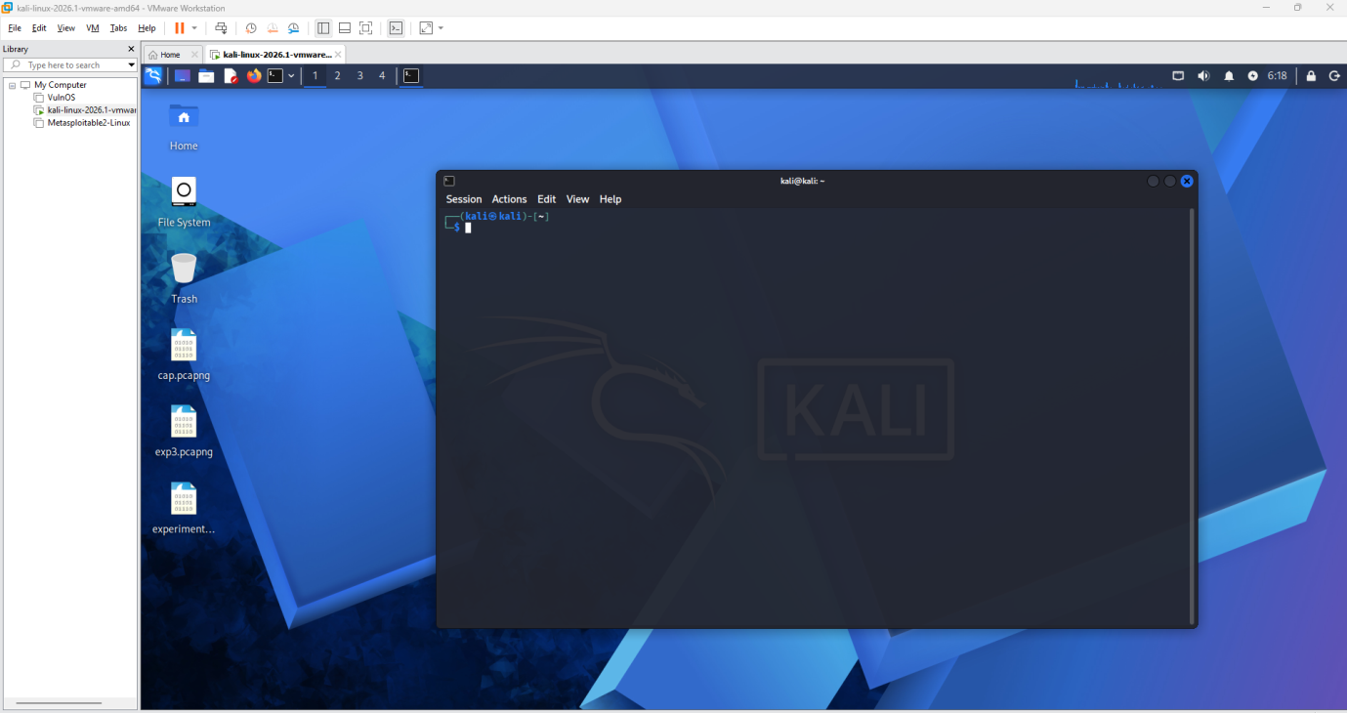

Step 2: Launch Wireshark
Type the following command:
Sudo wireshark
Or open it from:
Applications → Sniffing & Spoofing → Wireshark
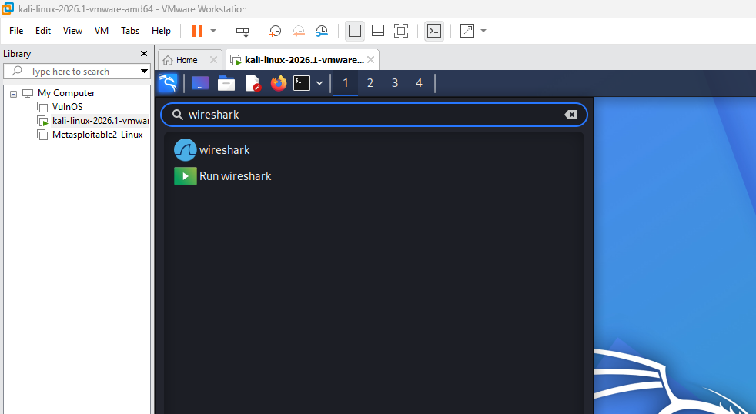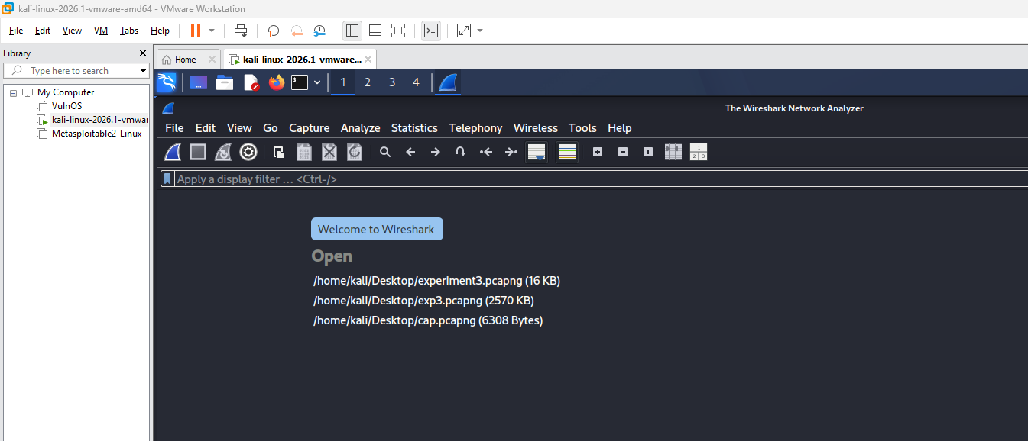

Step 3: Select a Network Interface
- Wireshark displays available interfaces.
- Select the active interface:
  - eth0 (Ethernet)
  - wlan0 (Wireless)
- Double-click the interface to start packet capturing.
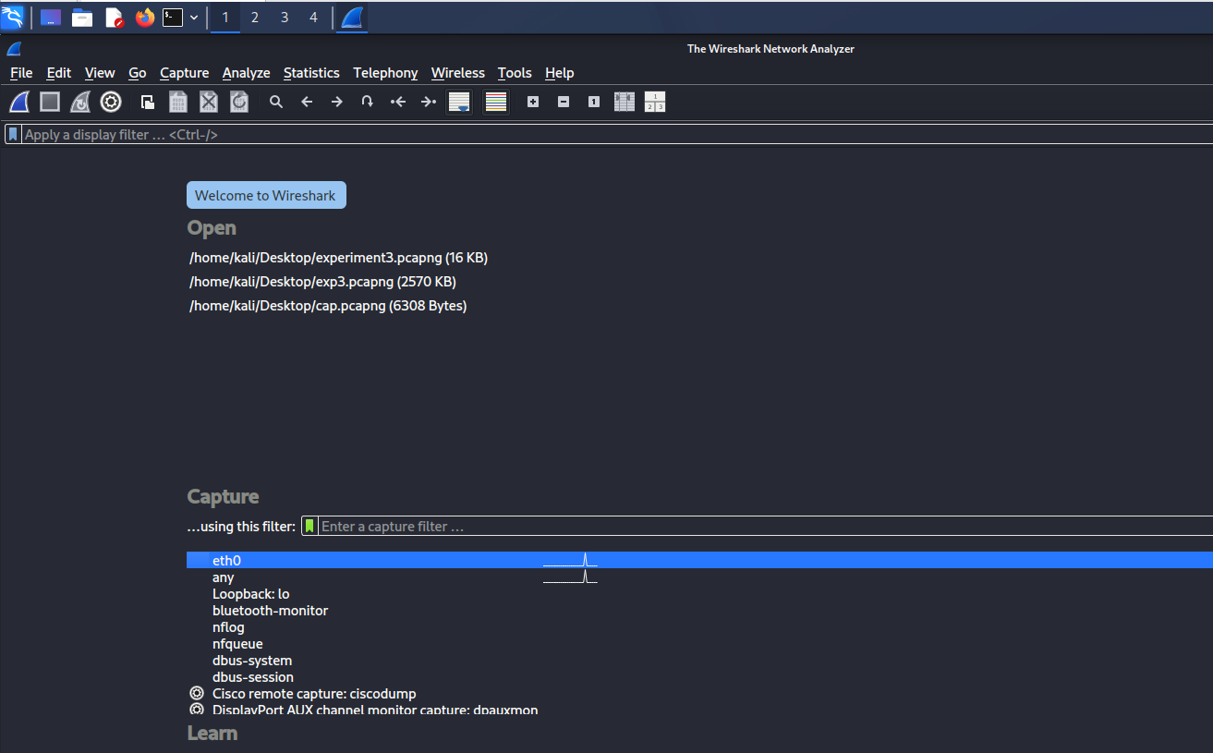
Step 4: Start Capturing Packets
- Click the blue Shark Fin icon.
- Network packets begin appearing in real time.
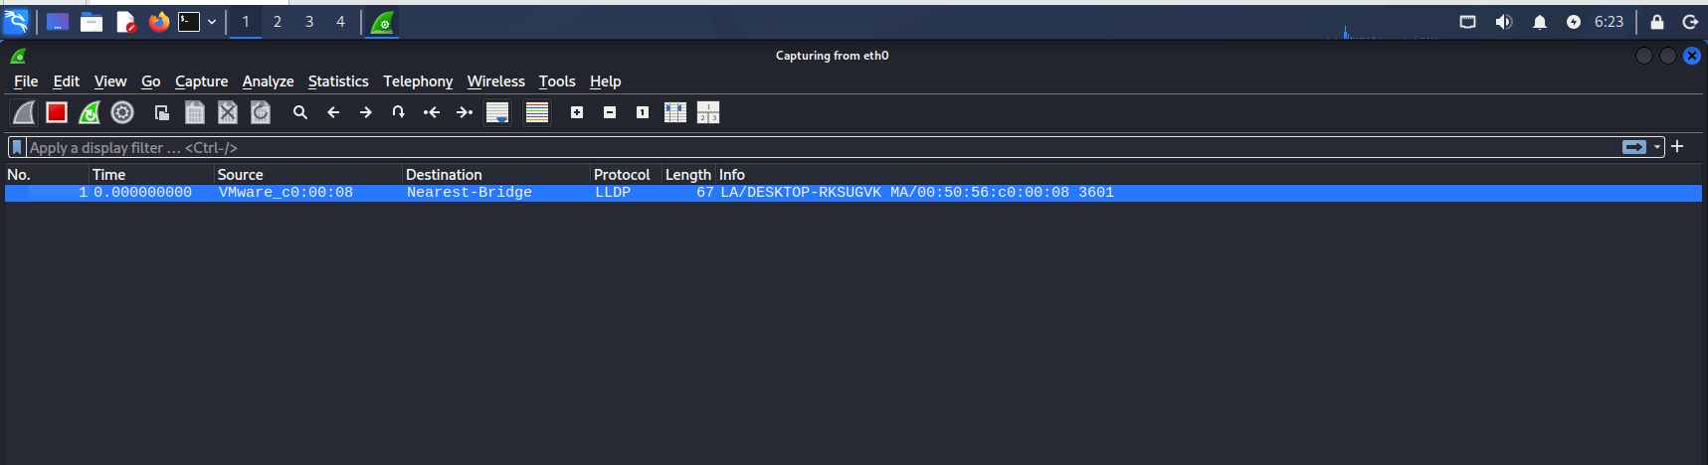
Step 5: Generate Network Traffic
Open a browser and visit websites such as:
https://www.google.com
https://www.wikipedia.org
Or execute:
ping google.com
This generates packets for analysis.
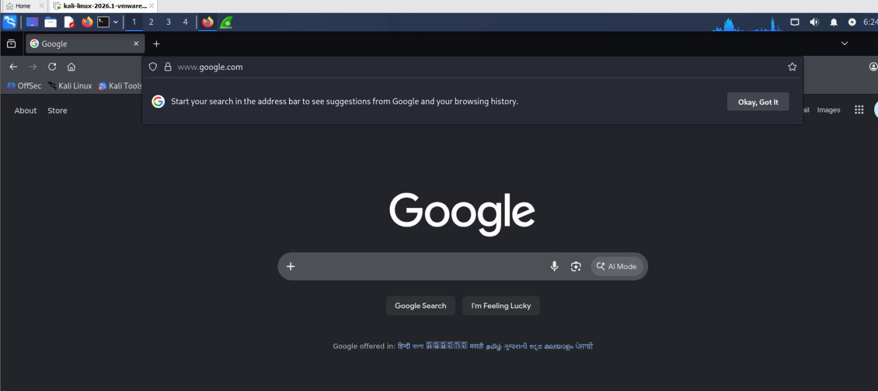

Step 6: Stop Packet Capture
- Click the red Stop button.
- Packet capture is halted.
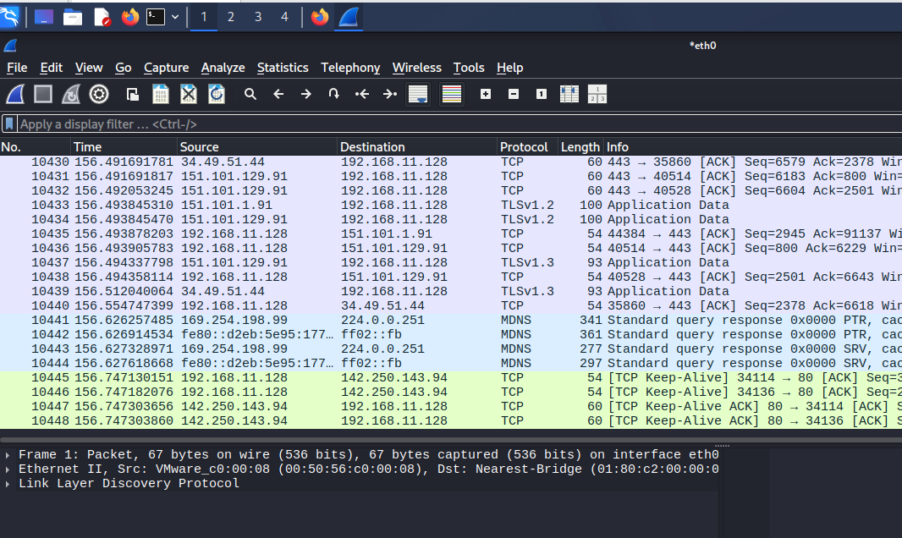
Step 7: Analyze Captured Packets
Observe the three Wireshark panes:
Packet List Pane
Displays captured packets.
Packet Details Pane
Shows protocol information.
Packet Bytes Pane
Displays packet contents in hexadecimal format.
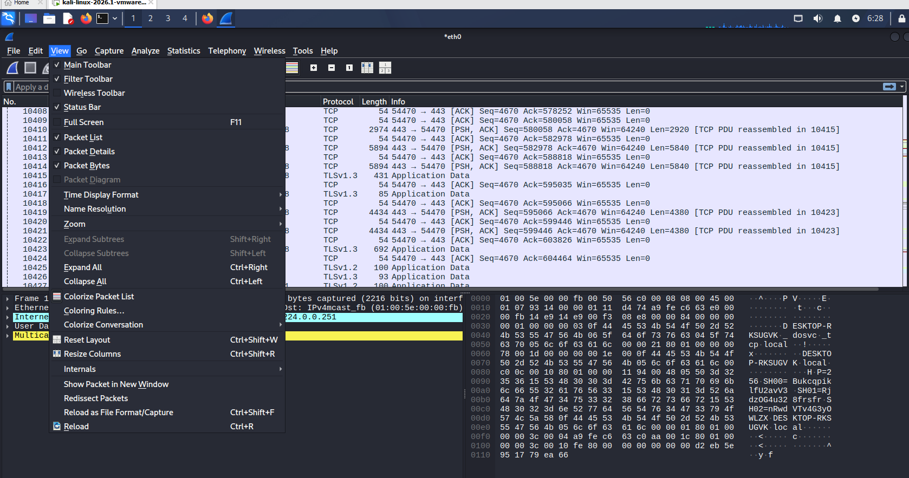
Step 8: Apply Display Filters
View HTTP Traffic-http
View DNS Traffic-dns
View TCP Packets-tcp
View ICMP (Ping) Packets-icmp
View Traffic from Specific IP-ip.addr == 8.8.8.8
Press Enter after entering the filter.
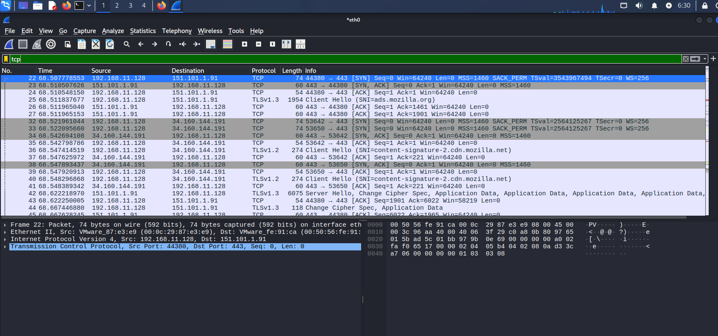
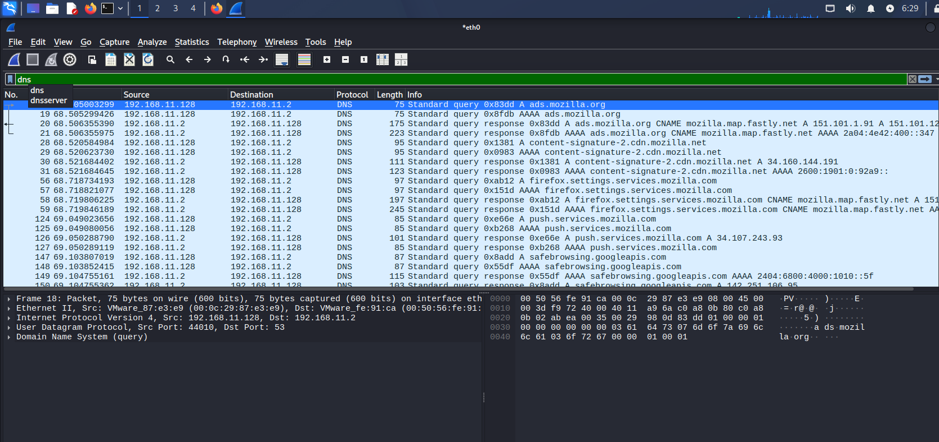
Step 9: Inspect Packet Details
- Select a packet.
- Expand:
  - Ethernet II
  - Internet Protocol (IP)
  - Transmission Control Protocol (TCP)
  - Hypertext Transfer Protocol (HTTP)
- Note:
  - Source IP Address
  - Destination IP Address
  - Protocol Used
  - Packet Length

Step 10: Follow a TCP Stream
- Right-click a TCP packet.
- Select:
Follow → TCP Stream
- View communication between client and server.
- Close the window after analysis.
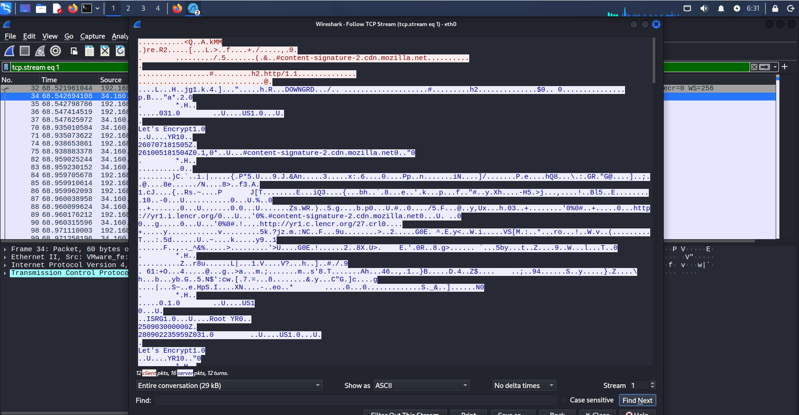
Step 11: Save the Capture
- Click File → Save As.
- Save as:
network_capture.pcapng
- Choose a destination folder.

Step 12: Reopen Saved Capture
- Select:
File → Open
- Browse to the saved. pcapng file.
- Open it for further analysis.
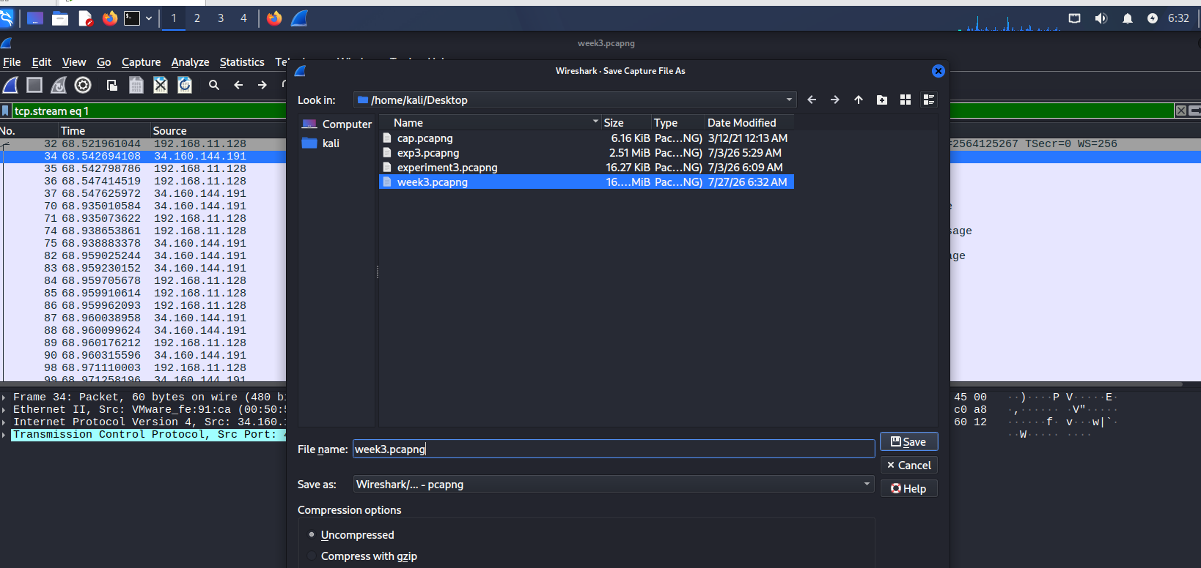

Result
Successfully captured and analysed network packets using Wireshark in Kali Linux. Various protocols such as TCP, DNS, HTTP, HTTPS, and ICMP were monitored and examined.

*Note: After executed each step, take screenshot from the system and pasted in their lab record*

